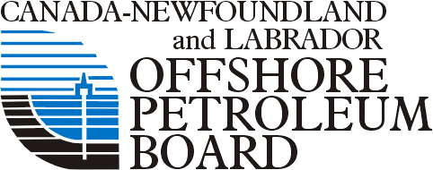
WESTERN NEWFOUNDLAND & LABRADOR OFFSHORE AREA
Strategic Environmental Assessment Update
Public Consultation Sessions

COMMENT / FEEDBACK FORM

The Canada-Newfoundland and Labrador Offshore Petroleum Board (C-NLOPB) is updating its Strategic Environmental Assessment (SEA) for the Western NL Offshore Area.

Through these consultations, we are interested in knowing about any questions or comments you may have regarding future petroleum activities in this area, as well as any other relevant information you may wish to share as input into the SEA Update.

What consultation session (location) did you attend?

Do you have any information about the existing environment in the area (oceanography, fish, birds, mammals, human activities) that you want to provide for the SEA Update?

Do you have any questions or comments regarding future petroleum activities in the region that you feel should be considered in the SEA Update?

Are there any specific measures that you think could be taken in relation to potential petroleum activities in the region that would help address your questions or comments?

Do you have any additional comments or information that you would like to provide related to the SEA Update and/or these open houses?

Thank you for participating in today’s Public Consultation Session.

Please leave your completed comment form at the Reception Desk, or send it to:

Steve Bonnell, AMEC Environment & Infrastructure
133 Crosbie Road, St. John’s NL PO Box 13216 A1B 4A5
Fax (709) 722-7353
Email steve.bonnell@amec.com

